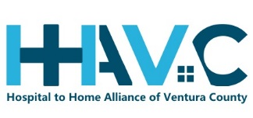

May 7, 2019
Agenda Items –

- Dementia Friendly update Sue
- Review PPT template for Quarterly All
- Review guest attendee process All
- SNF Update Frances
- Update on CA Master Plan on Aging; Ventura County Perspective Sue
- Draft protocol to address concern or barrier All
- Steering committee CFGS to HH Criteria All
- Sally Leave Sally

